

** Acoustic Event Recognition System**

***A Project Report submitted in partial fulfillment of the requirements for the award of the degree of***

**Bachelor of Technology**

**in**



** Computer Science and Engineering**

**by**

**Naveen Gupta**

**Roll No:181500417**

**Aryan Garg**

**Roll No: 181500135**

**Akash Sharma**

**Roll No: 181500059**

**Kush Sharma**

**Roll No: 181500343**

Under the Guidance of

Prof. Sandeep Kumar Rathore

**Department of Computer Engineering and Applications**

**GLA University, 17 km. Stone NH#2, Mathura-Delhi Road, Chaumuha, Mathura – 281406 U.P (India)**

**Declaration**

I/we hereby declare that the work which is being presented in the B.Tech. Project **“Acoustic Event Recognition System”**, in partial fulfillment of the requirements for the award ofthe ***Bachelor of Technology*** in Computer Science and Engineering and submitted to the Department of Computer Engineering and Applications of GLA University, Mathura, is an authentic record of my/our own work carried under the supervision of **Prof. Sandeep Kumar Rathore and Prof. Abhishek Verma.**

The contents of this project report, in full or in parts, have not been submitted to any other Institute or University for the award of any degree.

Sign Naveen Gupta Sign Aryan Garg

Name of Candidate: Naveen Gupta Name of Candidate: Aryan Garg

University Roll No.: 181500417 University Roll No.: 181500135

Sign Akash Sharma Sign Kush Sharma

Name of Candidate: Akash Sharma Name of Candidate: Kush Sharma

University Roll No.: 181500059 University Roll No.: 181500343

**Certificate**

This is to certify that the above statements made by the candidate are correct to the best of my/our knowledge and belief.

_______________________

**Supervisor**

Mr. Sandeep Kumar Rathore

Mentor

____________________ ____________________________

**Project Coordinator** **Program Co-ordinator**

(Mr. Mayank Srivastava) (Dr Anant Ram)

Date:

**ACKNOWLEDGEMENT**

In Current world of competition there is a race of existence in which those are having will power and dedication to fight this race succeed. A Project is like a connection between theoretical and practical knowledge. With this willing we joined this project. First of all, I would like to thank the Almighty God who is the one always guided us to the right path to work in our life. Then I would like to thank our parents and friends, who provided us their valuable suggestions during this project.

Next we would like to thank, our mentor Prof. Sandeep Kumar Rathore and our teacher Prof. Abhishek Verma for teaching us all needed technologies for this project, and every person who helped us in this project.

Signs Naveen Gupta, Aryan Garg, Akash Sharma, Kush Shrama

Naveen Gupta, Roll No: 181500417

Aryan Garg, Roll No: 181500135

Akash Sharma, Roll No: 18150059 Kush Sharma, Roll No: 181500343

**ABSTRACT**

The Project “Acoustic Event Recognition System” is a research based project. In this project we will recognize the events from the input audio files, Some events are “in the office”, “in the café”, “in the car”, “in the bus”, “in the forest”, etc. We used dataset of size 1.0Gb for this project. Which contains more than 450 audio files of .wav format and length of each audio file is 10 sec. In this dataset we have 14 classes of audio files. Our project will classify the audio files among these classes. For classification we extracted 26 features form audio files and used these features for classification. We have used many classification algorithms such as KNN classification in this algorithm we get 77% accuracy at k =3, 72% accuracy at k = 5, 68% accuracy at k=7, 61% accuracy at k = 13, then we applied Decision tree model in which we get 61% of accuracy, then we applied logistic regression model in which we get 24% accuracy, and then we applied Random Forest Algorithm in which we get 73% accuracy, and at last we applied Naïve bayes algorithm in which we get accuracy between 75% to 62%.

**List of Figures**

**Figure No. Figure Page No.**

1. Model Approach 3
2. Sample Image of Dataset 4
3. Sample Image of Dataset 4
4. Feature Extraction 5
5. Short Time Fourier Transform plot 6
6. Roll off Plot 6

7 Zero crossing rate plot 7

1. MFCC plot 7

9 KNN example 8

1. Decision Tree 8

11 Sigmoid Function Plot 9

12-21 Implementation of KNN 11-15

22-25 Decision Tree Implementation 16-17

26-29 Random Forest Implementation 18-19

30-33 Logistic regression Implementation 20-21

34-39 Naïve Bayes Implementation 22-24

40 Sample Project Model 25

41 Conclusion 26

**CONTENTS**

Declaration ii

Certificate ii

Acknowledge iii

Abstract iv

List of figures v

**CHAPTER 1 Introduction 1**

1.1 Overview and Motivation 1

1.2 Objective 1

1.3 Contribution 2 **CHAPTER 2 Literature Review 3**

2.1 Dataset 4

2.2 Feature Extraction 5

**CHAPTER 3 Proposed Work 8**

3.1 K-Nearest Neighbor 8

3.2 Decision tree 8

3.3 Logistic Regression 9

3.4 Random Forest 10

3.5 Naïve Bayes 10

**CHAPTER 4 Implementation and Result Analysis 11**

4.1 K-Nearest Neighbor 11

4.2 Decision Tree 16

4.3 Random Forest 18

4.4 Logistic Regression 20

4.5 Naïve Bayes 22

**CHAPTER 5 Conclusion 25**

**CHAPTER 6 References 27**

**Chapter 1**

**Introduction**

**1.1 Overview and Motivation**

Audio streams, such as broadcast news, meeting recordings, and personal videos contain sounds from a wide variety of sources

Examples include audio events related to human presence, such as

speech, laughter, or coughing, or to sounds of animals, objects, nature, or situations. The detection of these events is useful, e.g., for automatic tagging in audio indexing, automatic sound analysis for audio segmentation or audio context classification.

**1.2 objective:-**

Objective of our project is to recognize the Event on the basis of the input sound

Like bus**,** train, cafe, car, forest etc. through this input sound we have to recognized or detect which type of event can be perform at the moment. And also we are aware about what type of situation at that moment

This model can be help in recognized the health status of the patient like, activities occurring within a bathroom such as showering, washing-hands and brushing-teeth and events showing the health status such as cough or to detect equipment alarms in a neonatal intensive care unit.

**1.3 Contribution**

In this project we are applying different type of Algorithm for testing the model and find the appropriate accuracy level.

1:-Logistic regression

Logistic regression is a supervised learning classification algorithm used to predict the probability of a target variable.The nature of target or dependent variable is dichotomous, which means there would be only two possible classes.

Accuracy :-24%

2:-Decision tree

Decision Tree may be understood as the logical tree, is a range of conditions (premises) and actions (conclusions), which are depicted as nodes and the branches of the tree which link the premises with conclusions

-used for both Classification and Regression

Accuracy:-61%

3:-Random forest:-

Random Forest is a popular machine learning algorithm that belongs to the supervised learning technique. It can be used for both Classification and Regression problems in ML.

Accuracy:-73%

4:-KNN Algorithm

K-Nearest Neighbor is one of the simplest Machine Learning algorithms based on Supervised Learning technique. K-NN algorithm assumes the similarity between the new case/data and available cases and put the new case into the category that is most similar to the available categories.

-used for both Classification and Regression

Result-

Accuracy for k=3 :-77%

Accuracy for k=5 :- 72%

Accuracy for k=7 :- 68%

Accuracy for k=13 :- 61%

5:-Naive bayes:-

Naive Bayes is a probabilistic machine learning algorithm that can be used in a wide variety of classification tasks.

Accuracy:-75%

Accuracy:-68%

Accuracy:-63%

**Chapter 2**

**Literature Review**

Our Project has a dataset of audio type. As we can not use our dataset directly to train our model so we perform feature extraction.in which we extracted a set of feature

In our project we followed a approach where we first extract features from our dataset

Then these set of features is used for training our classification model then we use some part of data for testing our model

### Traditional classification algorithms and techniques:

### These are earlier classifiers and are based on traditional approach using either pixel based or region-based approach to extract features which are sent to the classifier for the detection of the type of skin cancer. These algorithms include techniques such as K-Nearest Neighbour (KNN), Naive Bayesian Algorithm, SVM and ANN Classifiers.

### 

Figure 1- Project Approach

**2.1 Dataset**

In this Project we have used the dataset of Audio files. In this dataset all files are in .wav format of size 1gb (approx.). Our dataset has 458 audio files and each of length 10 seconds. And there are 14 classes in our data set these are Beach, Bus, Café, Car, City_centre, Forest_path, Grocery_store, Home, Libarary, Metro_station, Office, Park, Residential_area, Train.

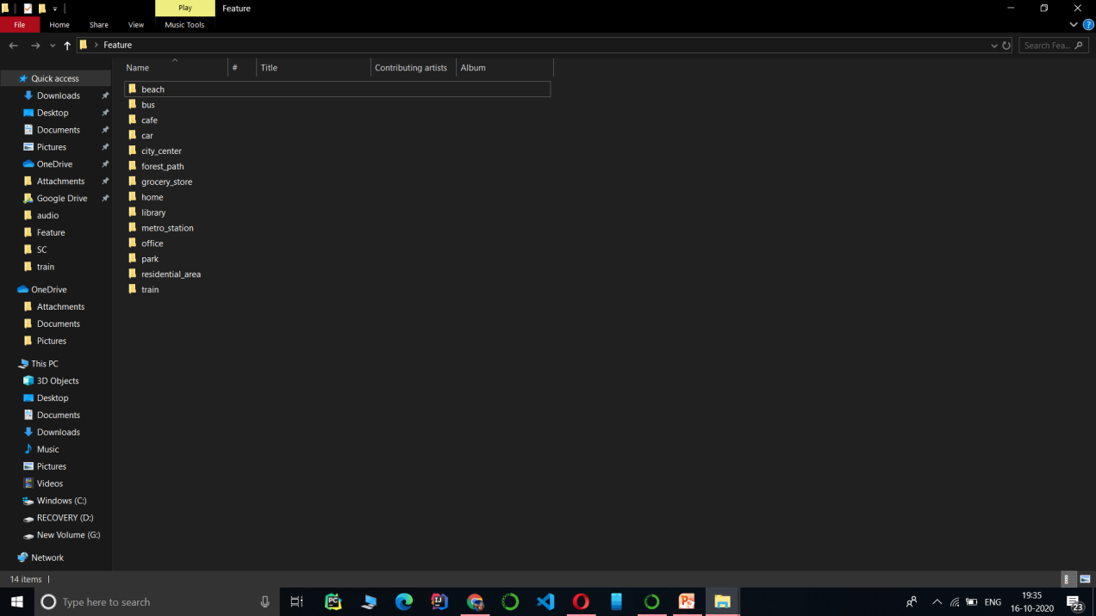

Figure 2- Sample Image of the Dataset

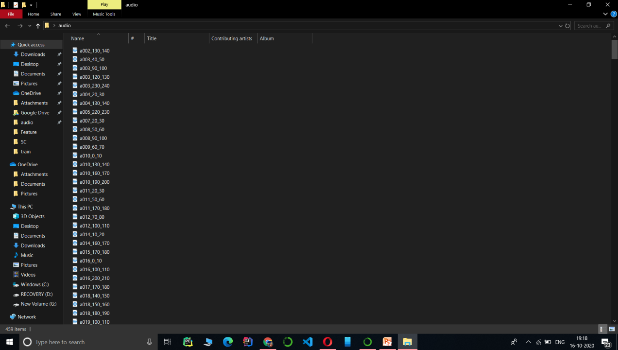

Figure 3- Sample Image of the Dataset

**2.2 Feature Extraction**

The data provided in our data set is in audio (.wav) format which cannot be understood by the models directly. So we need to convert them into an understandable format for which feature extraction is used. It is a process that explains most of the data in an understandable way which can be used in different models to train. Feature extraction is required for classification, prediction algorithms.

In our project we have extracted 26 features from each audio file. These features are Chroma_stft, rmse, spectral_centroid, spectral_bandwidth, roll_off, zero_crossing_rate, Mel-frequency cepstral coefficients (mfcc) (1-20).

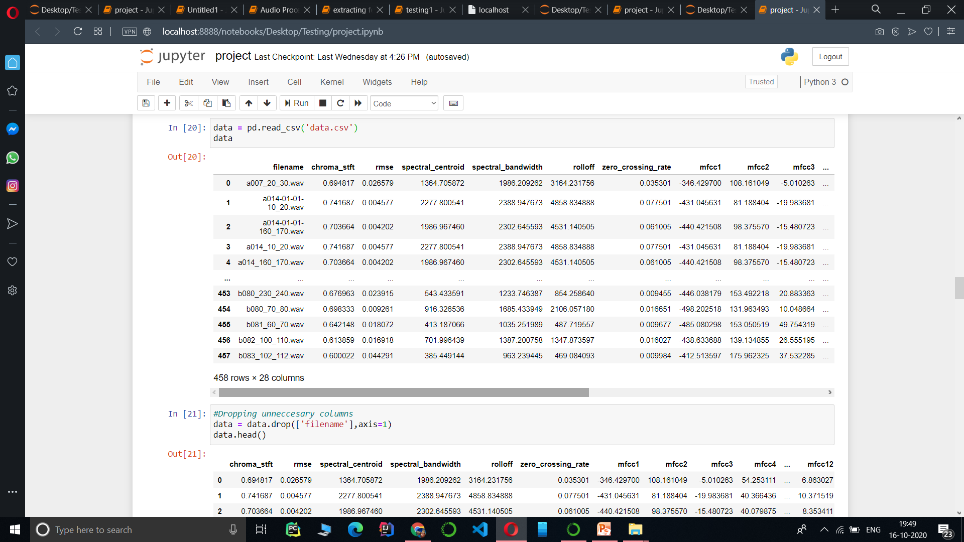

Figure 4- Image of feature Extraction

**Rmse-** It is defined as root mean square energy in a audio signal.

**Spectral centroid-** The spectral centroid is a measure which used in digital signal processing to characterize a spectrum. It indicates where the center of mass of the spectrum is located. it has a robust connection with the impression of brightness of a sound.

**Chroma stft -** Chroma features are an interesting and powerful representation for music audio in which the entire spectrum is projected onto 12 bins representing the 12 distinct semitones (or chroma) of the musical octave.

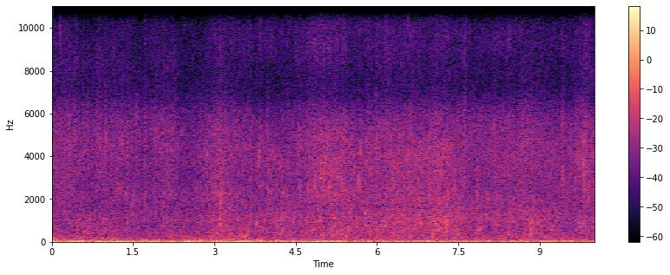

Figure 5- Short time fourier transform plot.

**Spectral Bandwidth**- it is the Wavelength interval in which a radiated spectral quantity is not less than half its maximum value.

**Roll off -** Roll off refers to the action of a specific type of filter; one designed to roll off frequencies above or below a certain point.The sound is gently “rolled off” with frequencies further above or below the cutoff frequency becoming more and more attenuated.

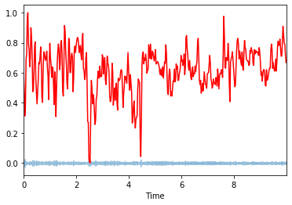

Figure 6- Roll off plot

**Zero crossing rate-** The zero-crossing rate is the rate of sign-changes along a signal, means the rate at which the signal changes from positive to zero to negative or from negative to zero to positive. This feature has been used heavily in music information and speech recognition, it is one of the key feature.

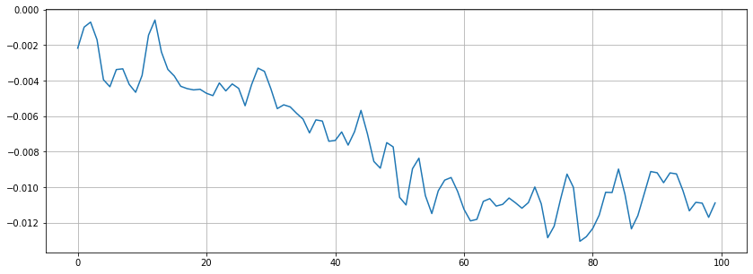

Figure 7- Zero crossing rate -0

**Mfcc -** Mel-frequency cepstral coefficients (MFCC) takes into account human perception for sensitivity at appropriate frequencies by converting the conventional frequency to Mel Scale, that’s why suitable for speech recognition tasks.

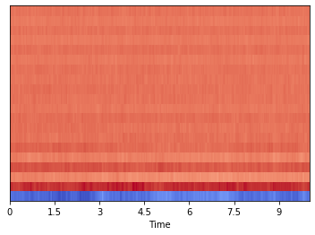

Figure 8 – mfcc plot

**Chapter 3**

**Proposed work**

For classification purpose we used different-different classification algorithms such as Decision Tree, K nearest neighbor, Logistic Regression, Random Forest, Naïve bayes.

**3.1 KNN**

KNN is a type of supervised learning machine algorithm. It is used for classification as well as regression. But it is mainly used for classification algorithm. KNN is a lazy learning algorithm because it does not have a training phase and uses all the while testing phase.

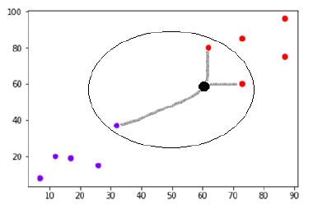

Figure 9- KNN example

**3.2 Decision Tree Algorithm**

Decision Tree algorithm is a supervised learning algorithm. It is used for solving regression and classification problems.

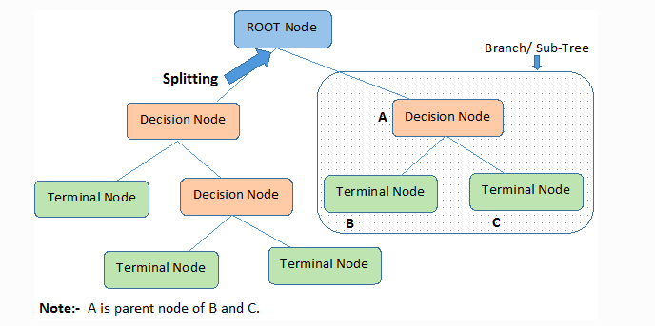

Figure 10 – Decision Tree

1. **Root Node:**It represents the entire population or sample and this further gets divided into two or more homogeneous sets.
2. **Splitting:**It is a process of dividing a node into two or more sub-nodes.
3. **Decision Node:**When a sub-node splits into further sub-nodes, then it is called the decision node.
4. **Leaf / Terminal Node:**Nodes do not split is called Leaf or Terminal node.
5. **Pruning:**When we remove sub-nodes of a decision node, this process is called pruning. You can say the opposite process of splitting.
6. **Branch / Sub-Tree:**A subsection of the entire tree is called branch or sub-tree.
7. **Parent and Child Node:**A node, which is divided into sub-nodes is called a parent node of sub-nodes whereas sub-nodes are the child of a parent node.

**3.3 Logistic Regression Algorithm**

Logistic Regression is a Machine Learning algorithm which is used for the classification problems. This is a predictive analysis algorithm and based on the concept of probability. Logistic regression is probably the most widely used general-purpose classifier. It uses sigmoid function for output and It is very scalable and can be very fast to train. Some applications are

• Spam filtering

• News message classification

• Web site classification



Figure 11- Plot of sigmoid function

**3.4 Random Forest**

Random forests or random decision forests are an ensemble learning method for classification, regression and other tasks that operate by constructing a multitude of decision trees at training time and outputting the class that is the mode of the classes (classification) or mean/average prediction (regression) of the individual trees. Random decision forests correct for decision trees' habit of over fitting to their training set. Random forests generally outperform decision trees, but their accuracy is lower than gradient boosted trees. However, data characteristics can affect their performance.

Random forest adds additional randomness to the model, during growing the trees. Instead of searching for the most important feature while splitting a node, it searches for the best feature among a random subset of features.

**3.5 Naïve Bayes**

A naive Bayes classifier is an algorithm that uses Bayes' theorem to classify objects. Naive Bayes classifiers assume strong, or naive, independence between attributes of data points. Popular uses of naive Bayes classifiers include spam filters, text analysis and medical diagnosis. These classifiers are widely used for machine learning because they are simple to implement.

Naive Bayes is also known as simple Bayes or independence Bayes.

**Chapter 4**

**Implementation and Result Analysis**

**4.1 KNN**

In KNN we get

* **Accuracy for k = 3 is 77%.**
* **Accuracy for k = 5 is 72%**
* **Accuracy for k = 7 is 68%**
* **Accuracy for k = 13 is 61%**

**Snapshots**

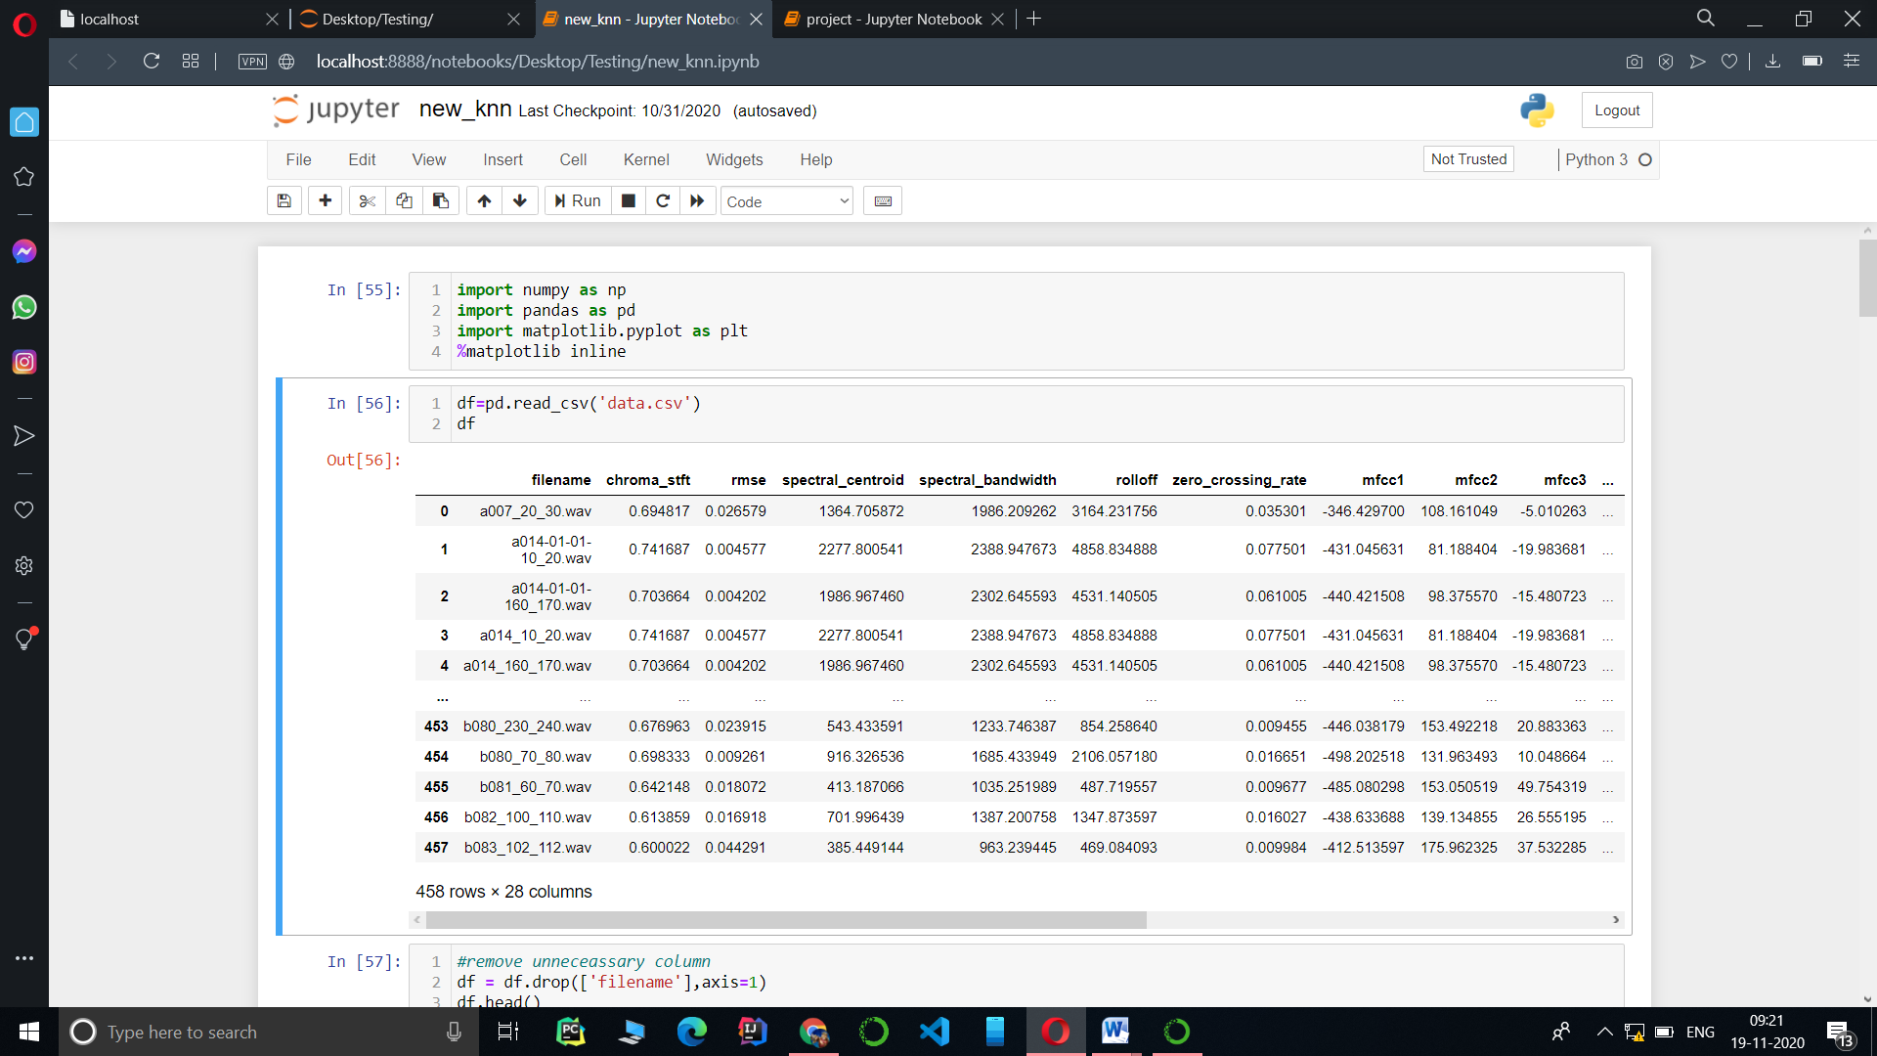

Figure 12: implementation of KNN

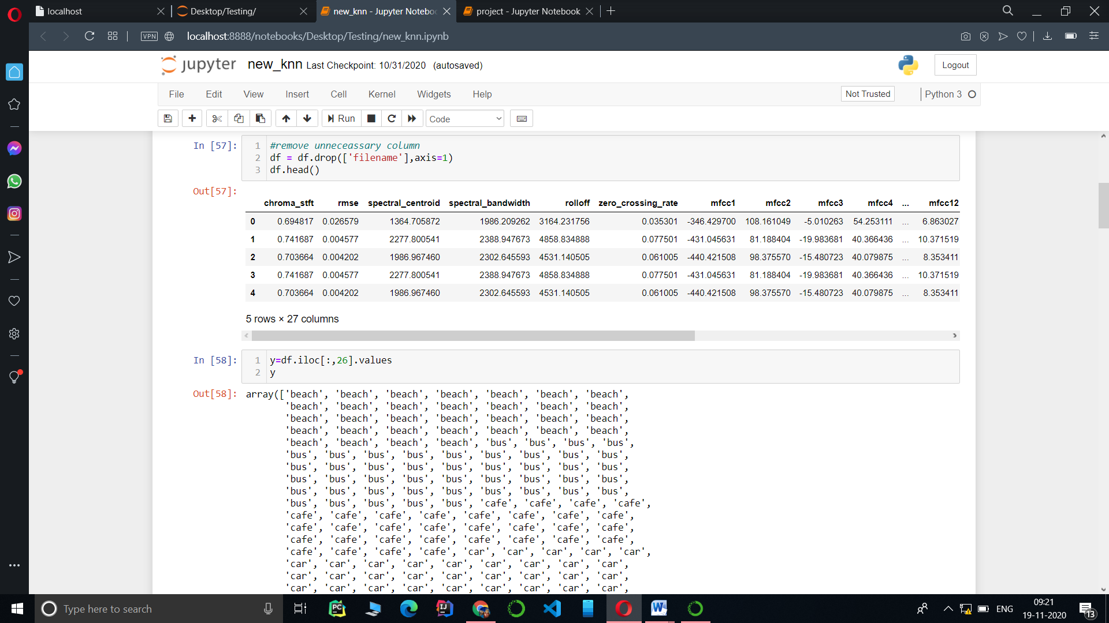

Figure 13: Implementation of knn

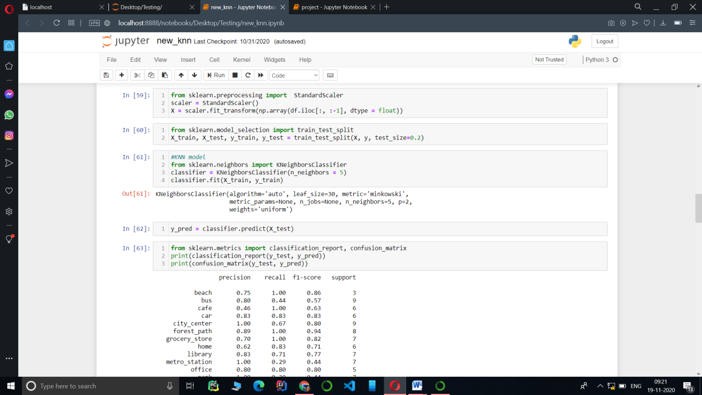

Figure 14- Implementation of KNN

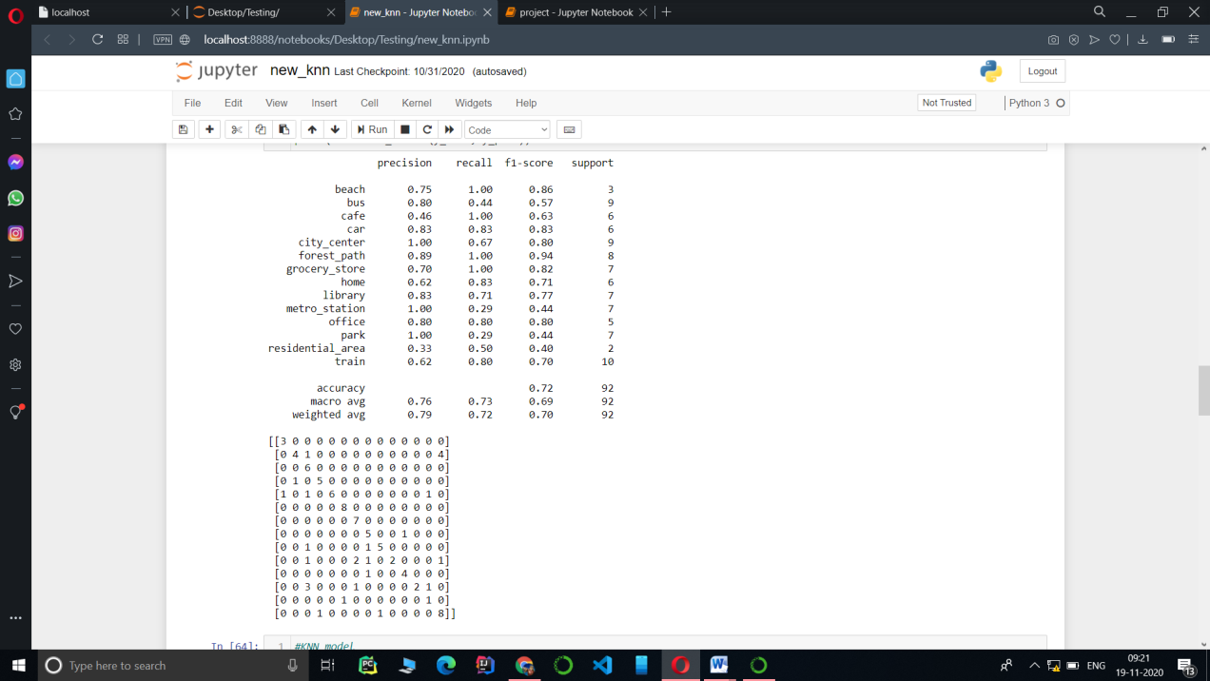

Figure 15- Implementation of KNN

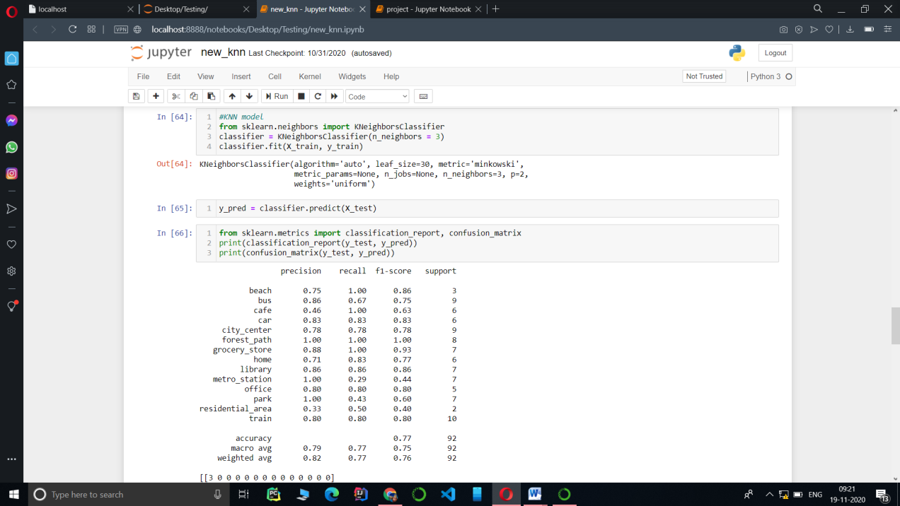

Figure 16 Implementation of KNN

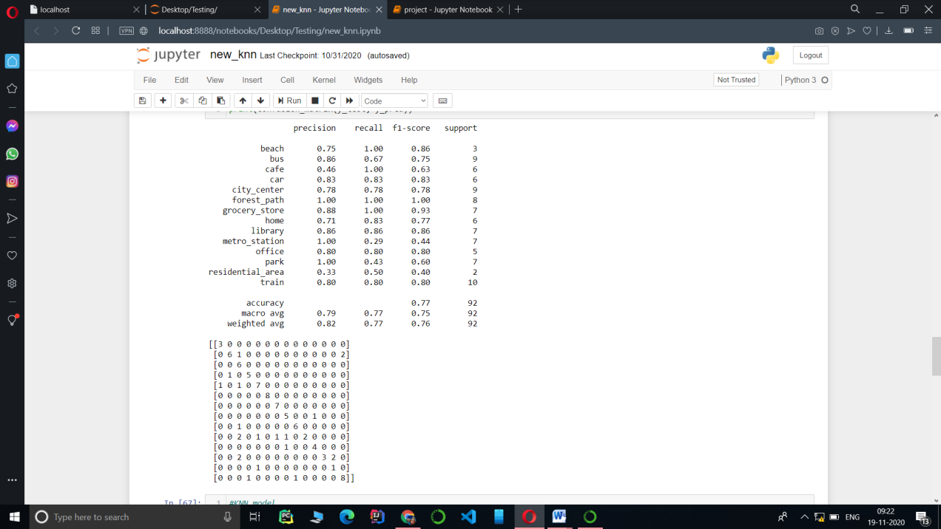

Figure 17: Implementation of KNN

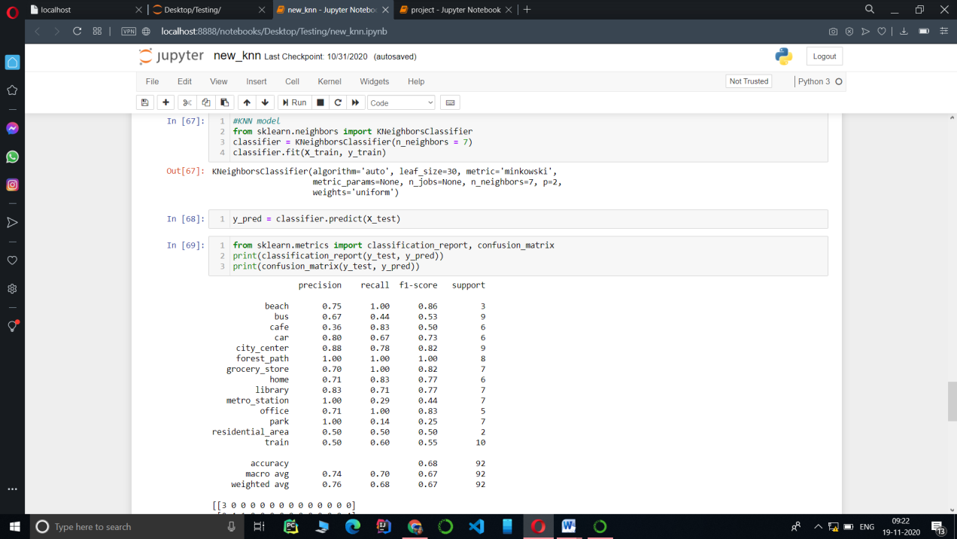

Figure 18: Implementation of KNN

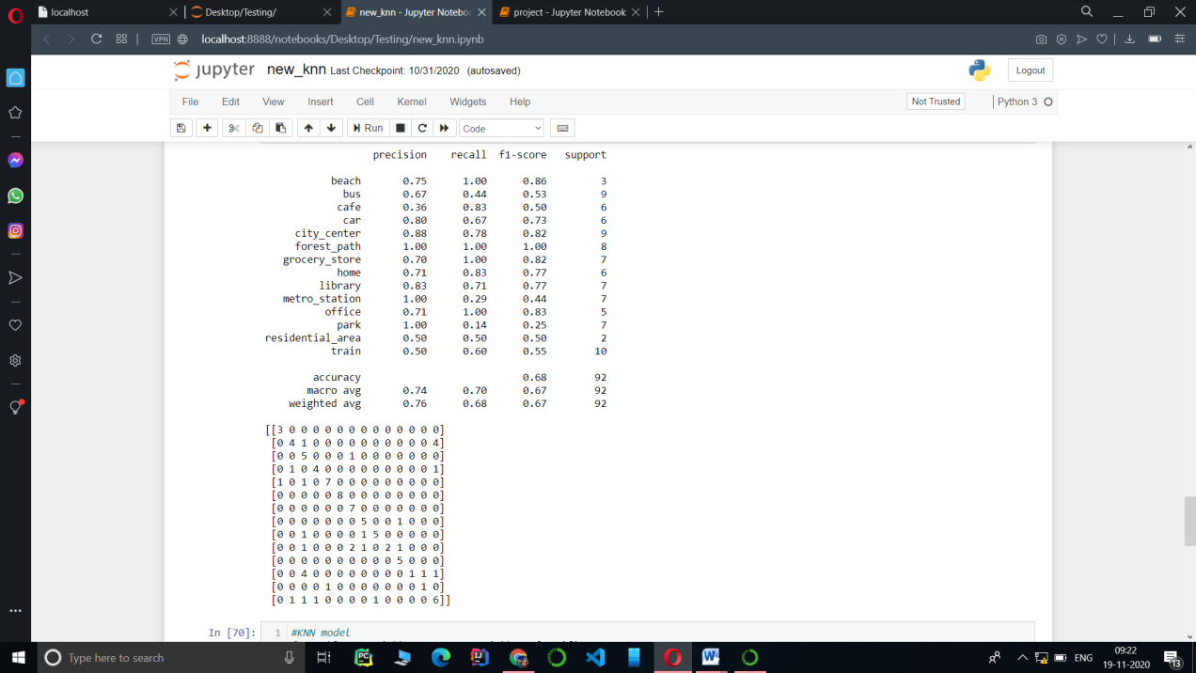

Figure 19: Implementation of KNN

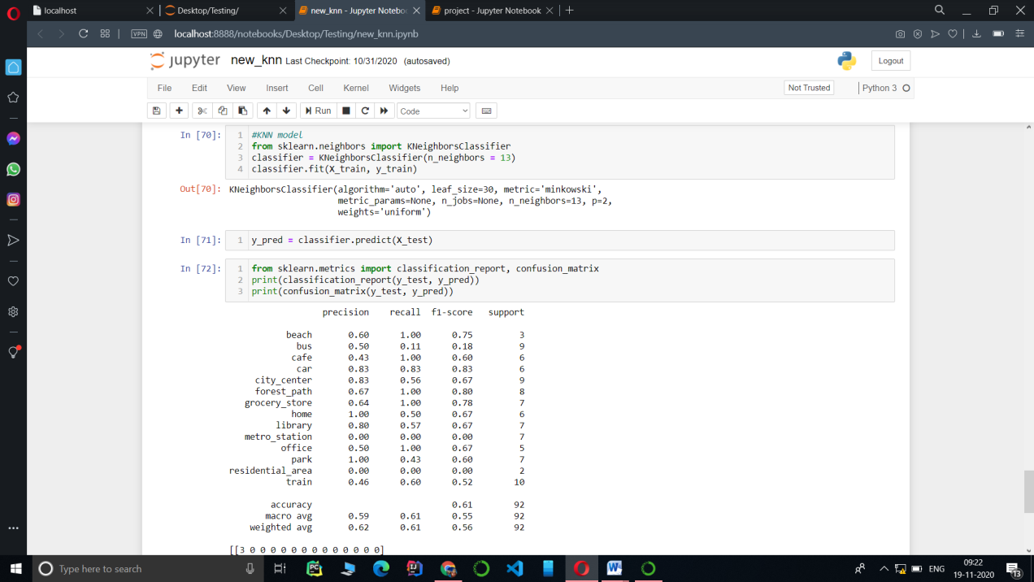

Figure 20- Implementation of KNN

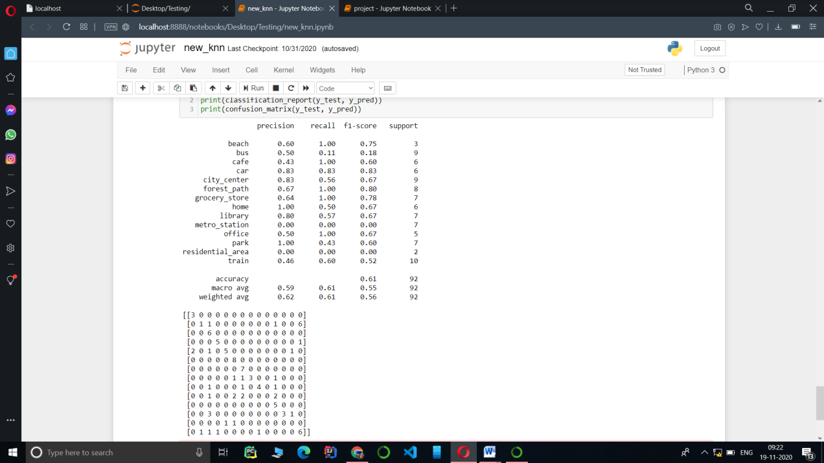

Figure 21 – Implementation of KNN

**4.2 Decision Tree Algorithm**

We get Accuracy of **61%** in Decision Tree Algorithm

**Snapshots**

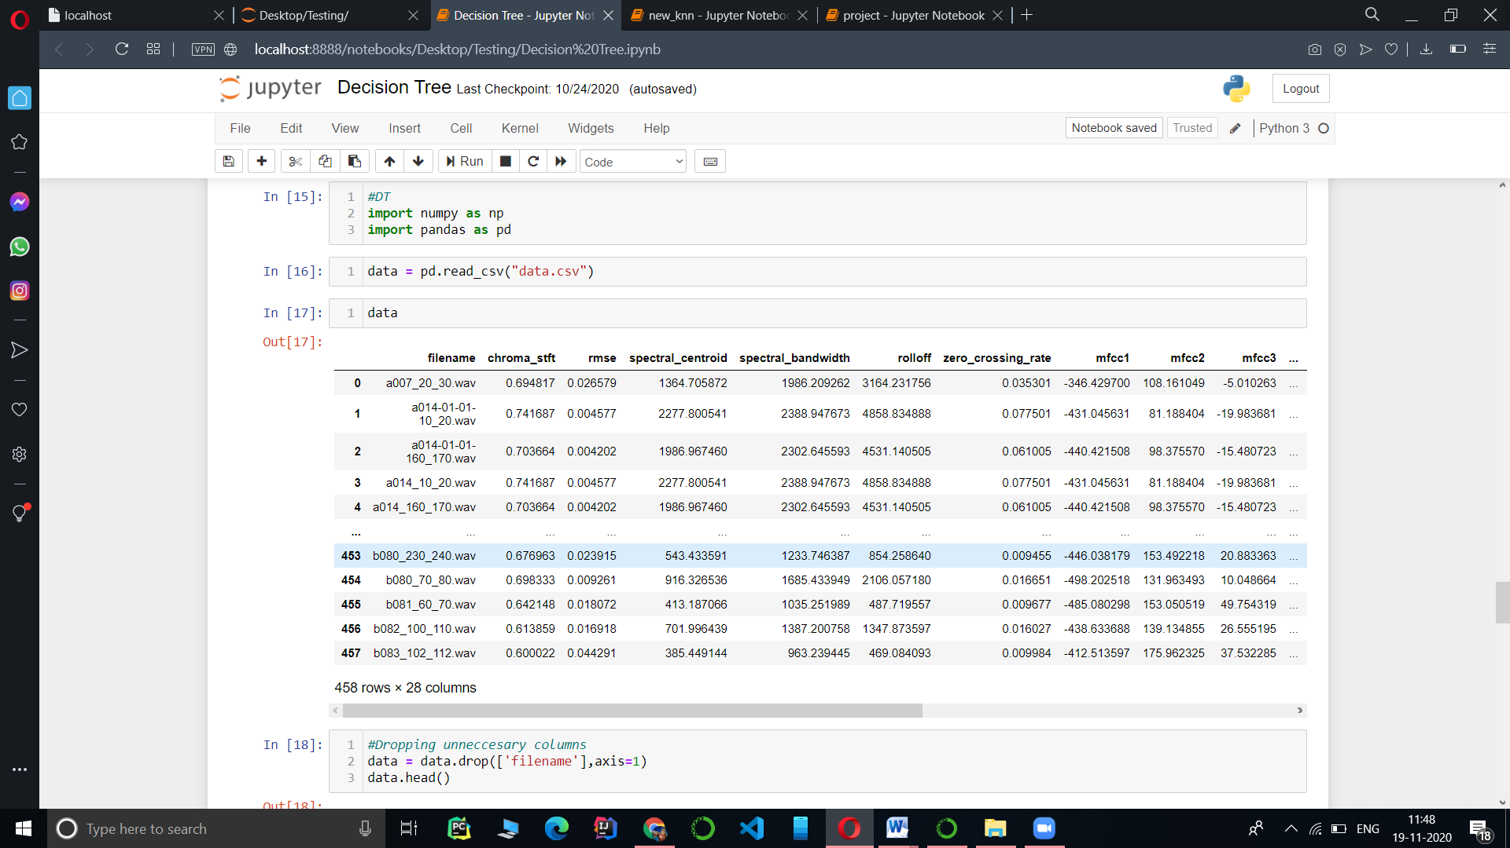

Figure 22-Decision Tree Implementation

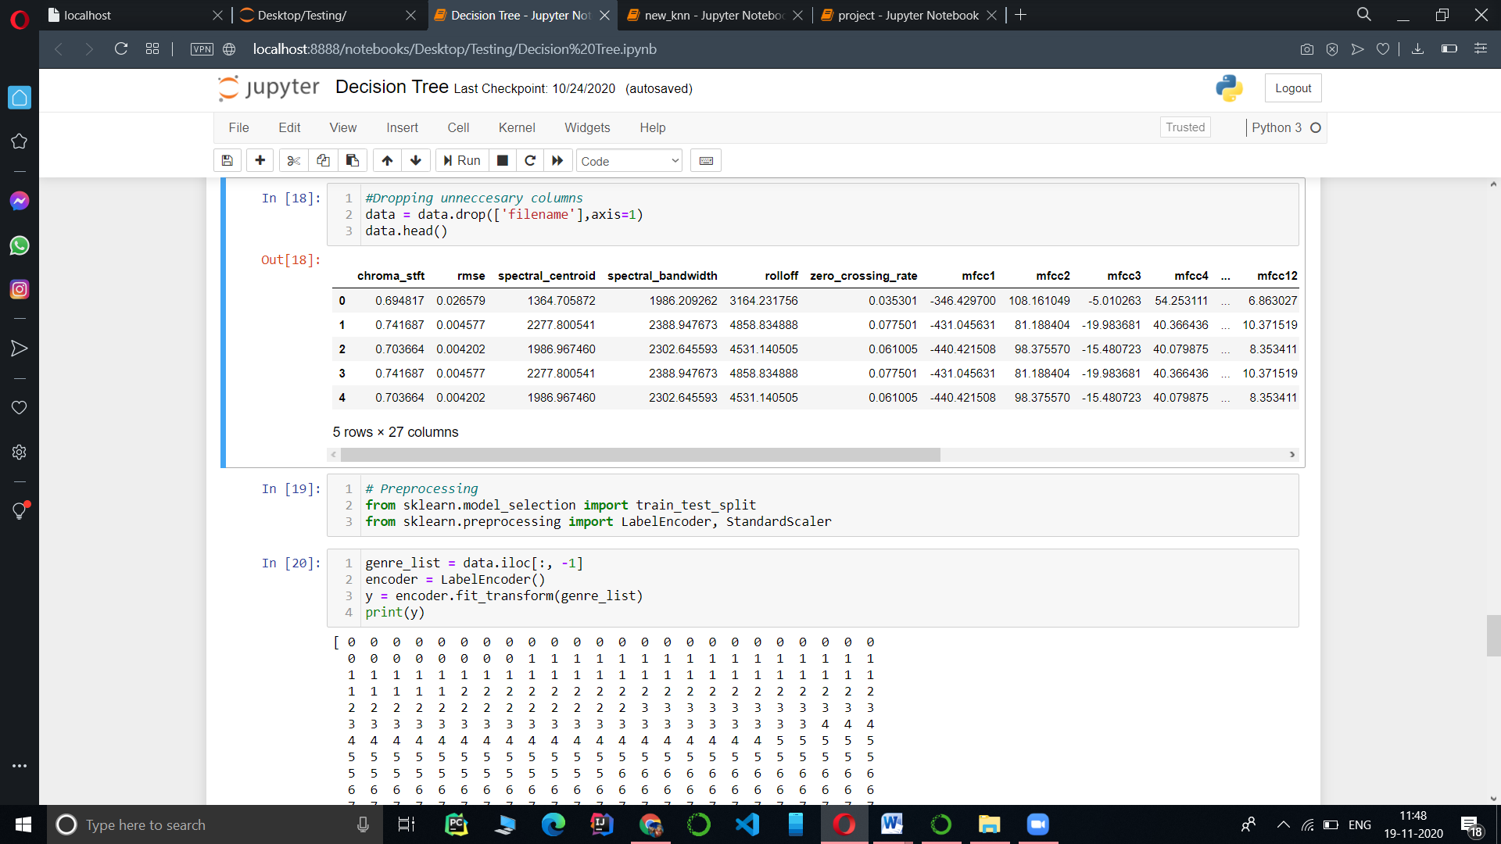

Figure 23- Decision Tree Implementation

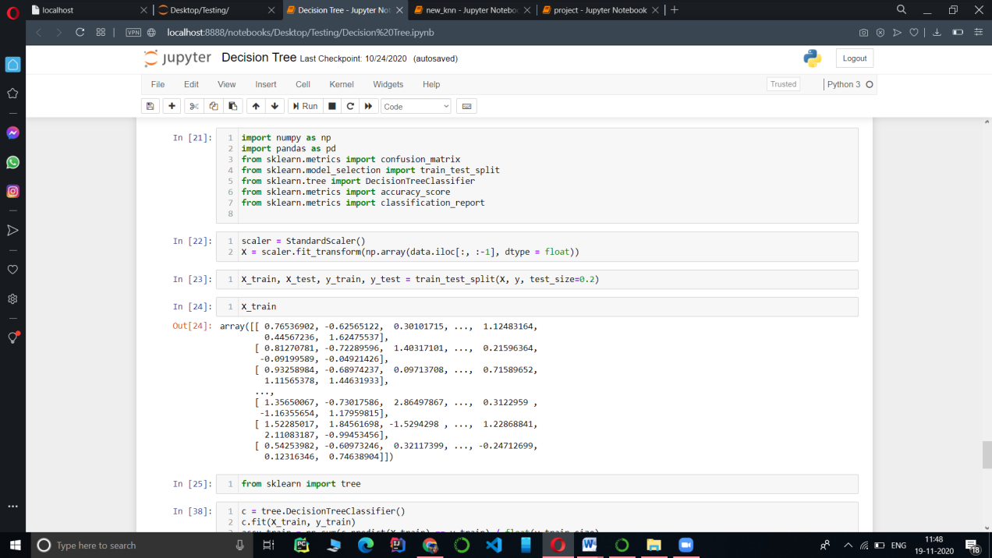

Figure 24-Decision Tree Implementation

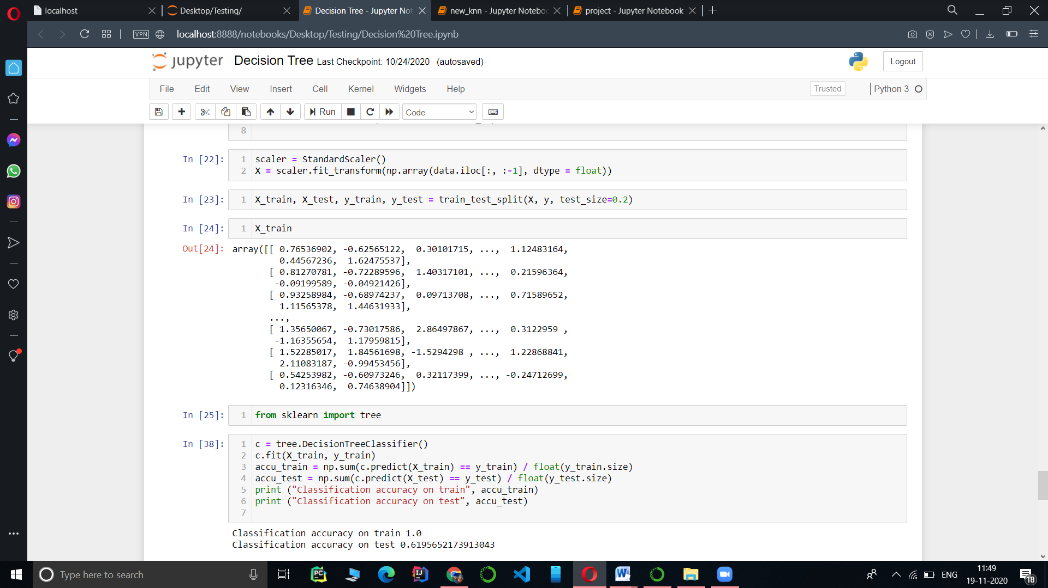

Figure 25- Decision Tree Implementation

**4.3 Random Forest Algorithm**

We get Accuracy of **72%** in Random Forest Algorithm

**Snapshots**

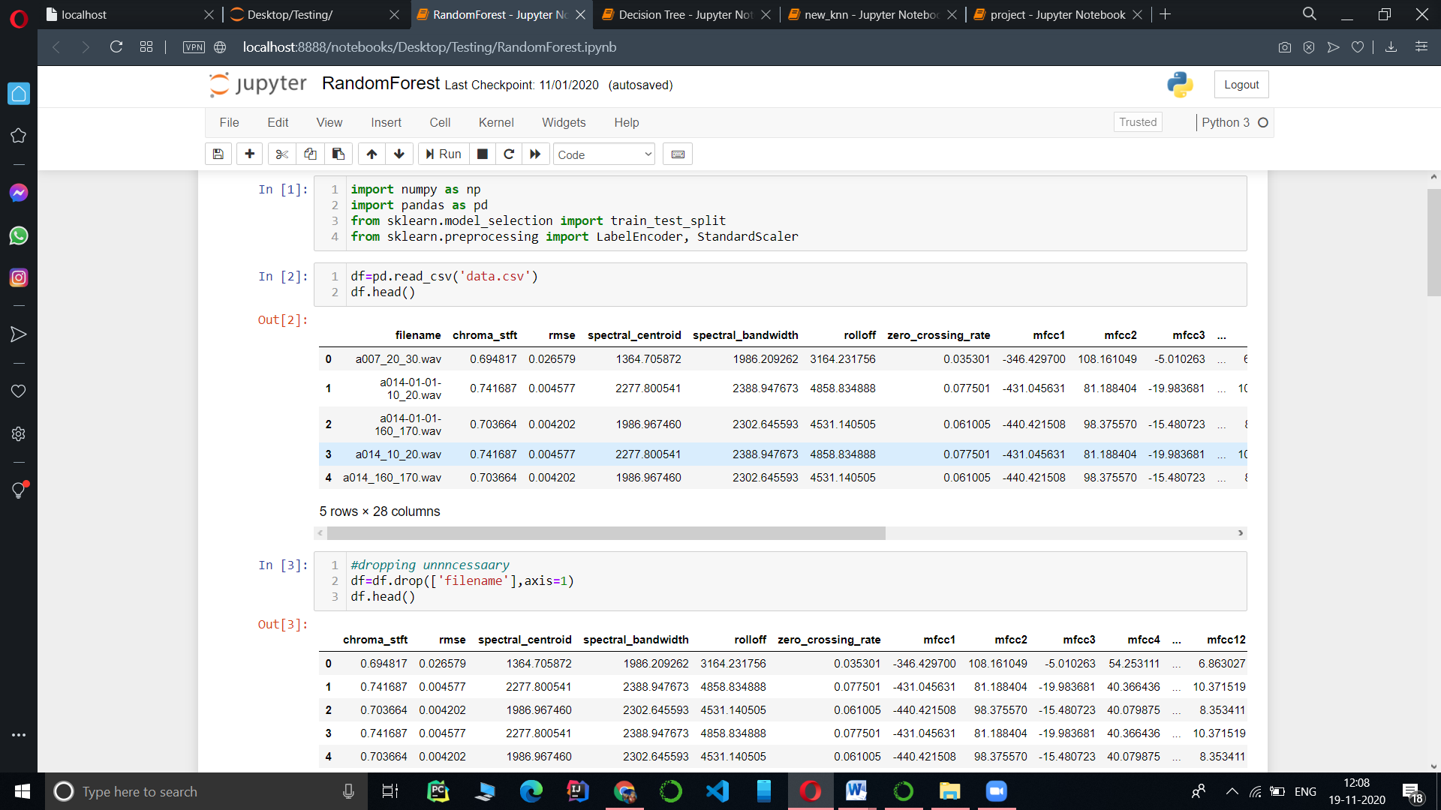

Figure 26- Random Forest Implementation

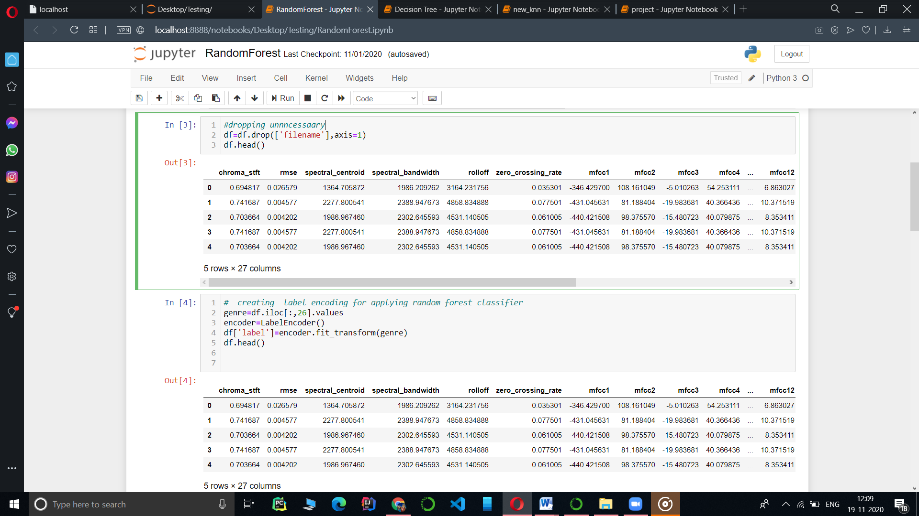

Figure 27- Random Forest Implementation

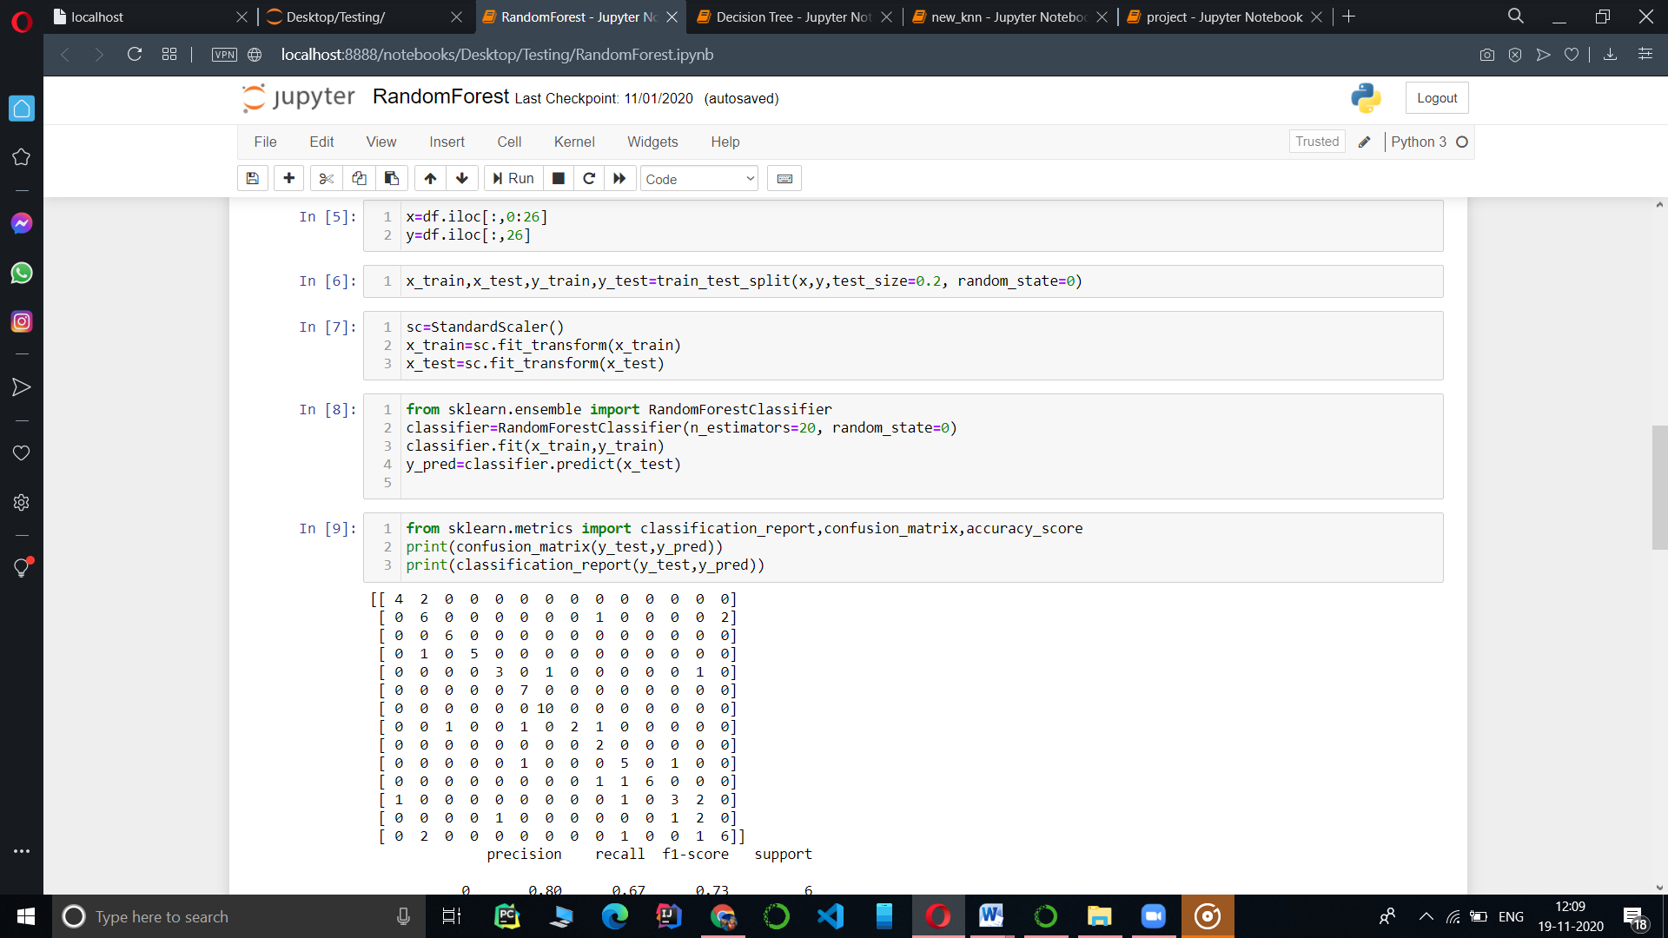

Figure 28- Random Forest Implementation

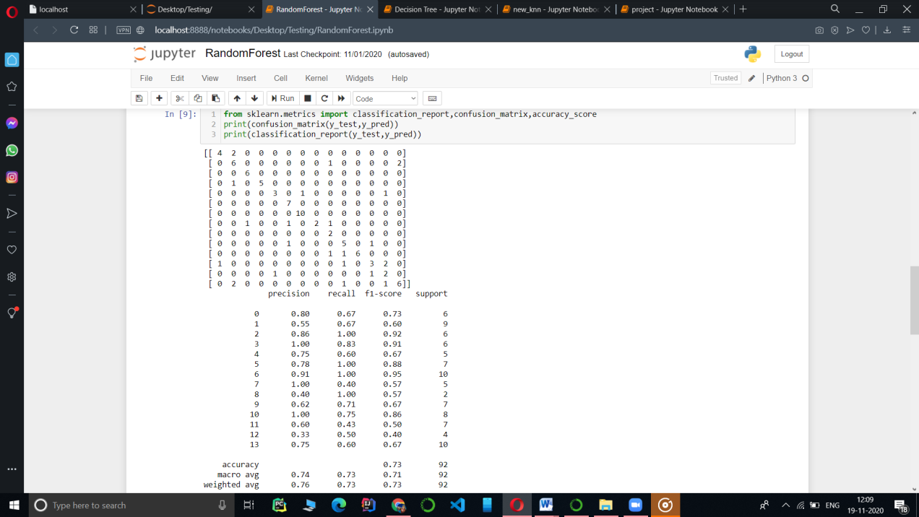

Figure 29- Random Forest Implementation

**4.4 Logistic Regression Algorithm**

We get Accuracy of **24%** in Logistic Regression

**Snapshots**

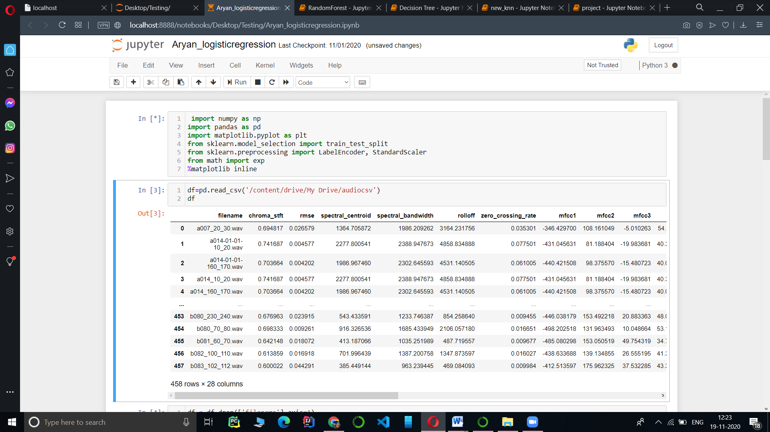

Figure 30- Logistic Regression Implementation

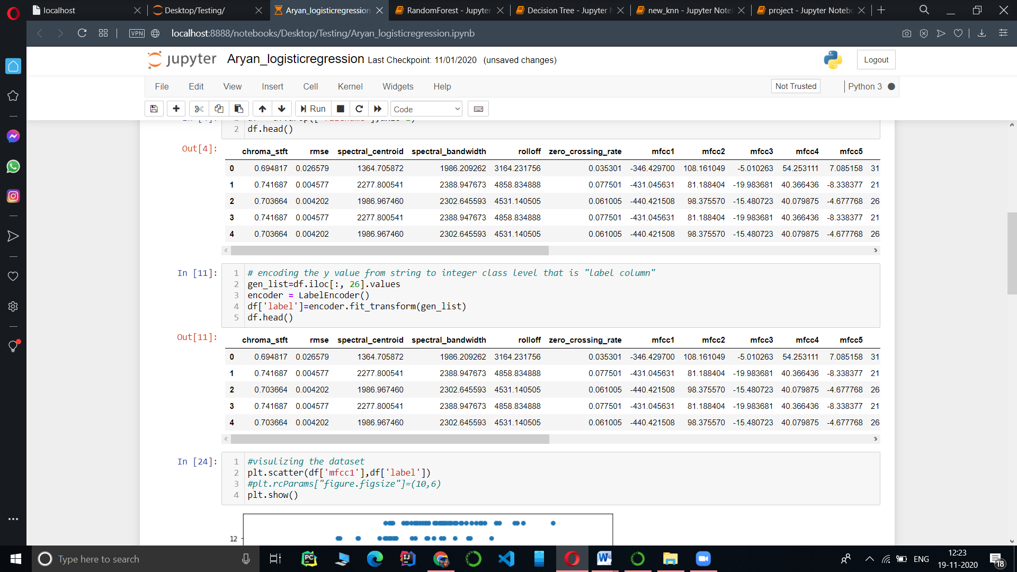

Figure 31- Logistic Regression Implementation

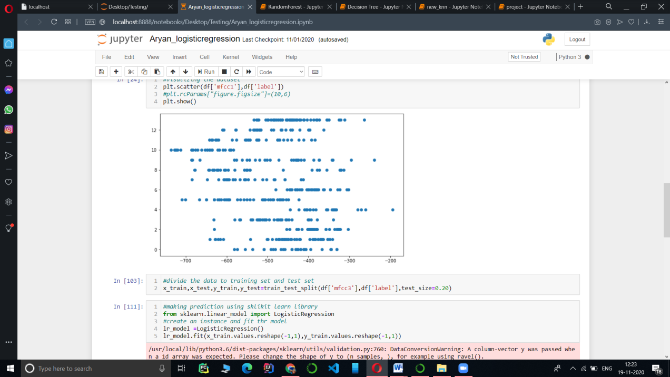

Figure-32- Logistic Regression Implementation

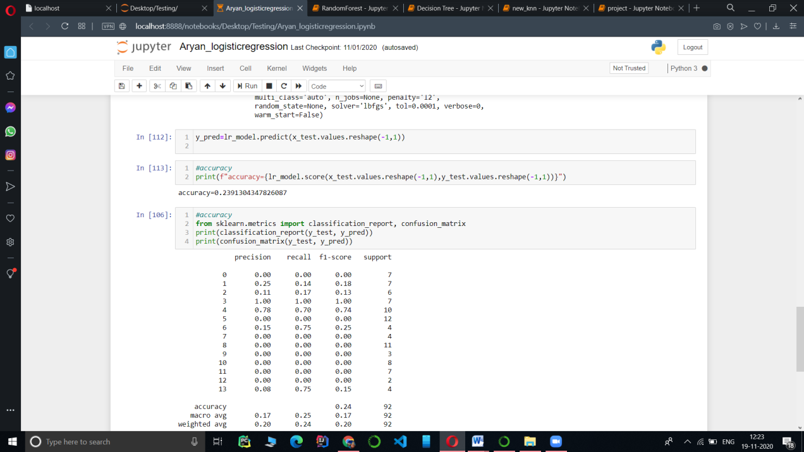

Figure 33-Logistic Regression Implementation

**4.5 Naïve Bayes Algorithm**

We get Accuracy of **68% in** Naïve Bayes Algorithm

**Snapshots**

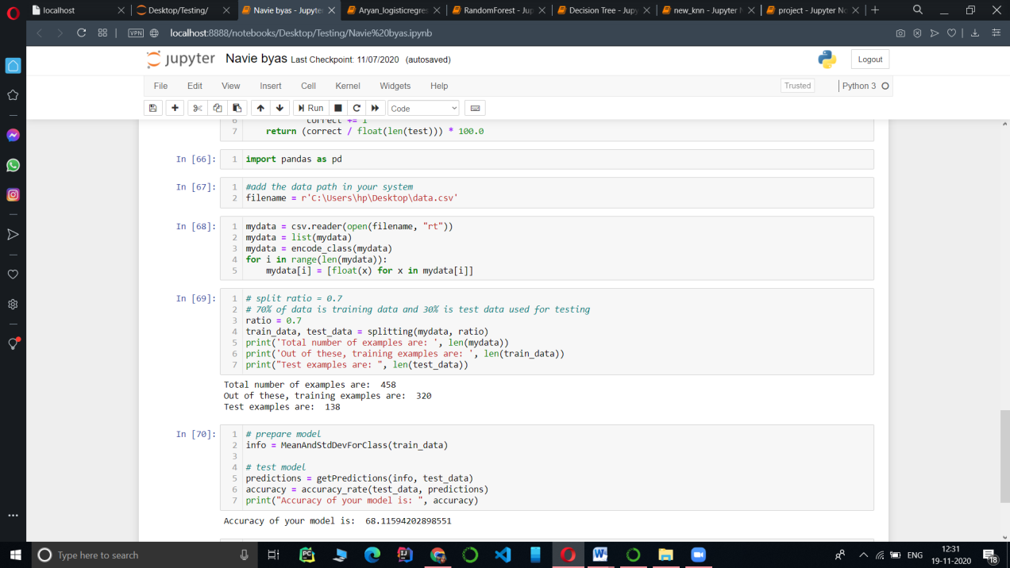

Figure 34- Naïve Bayes Implementation

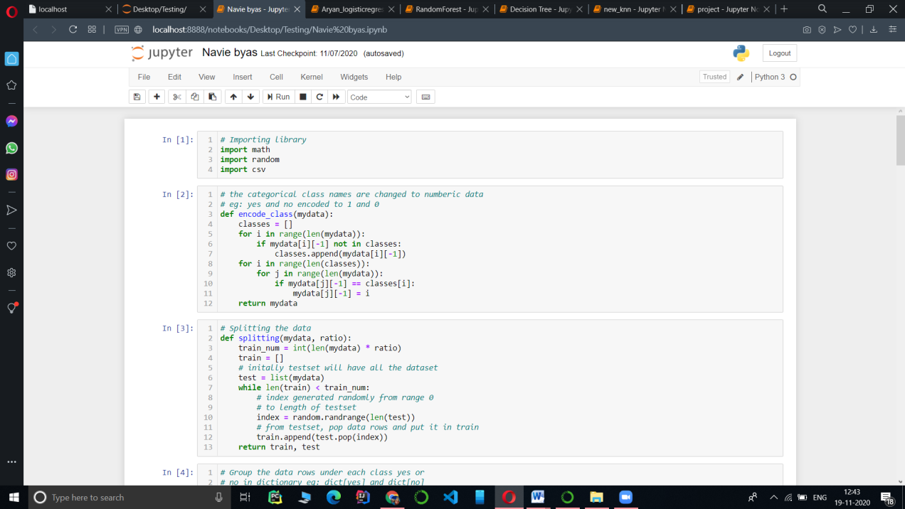

Figure 35- Naïve Bayes Implementation

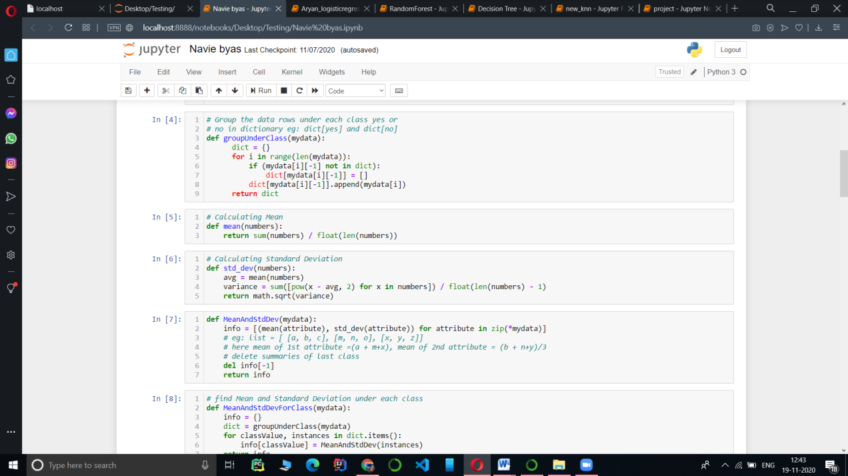

Figure 36 :-Naïve Bayes Implementation

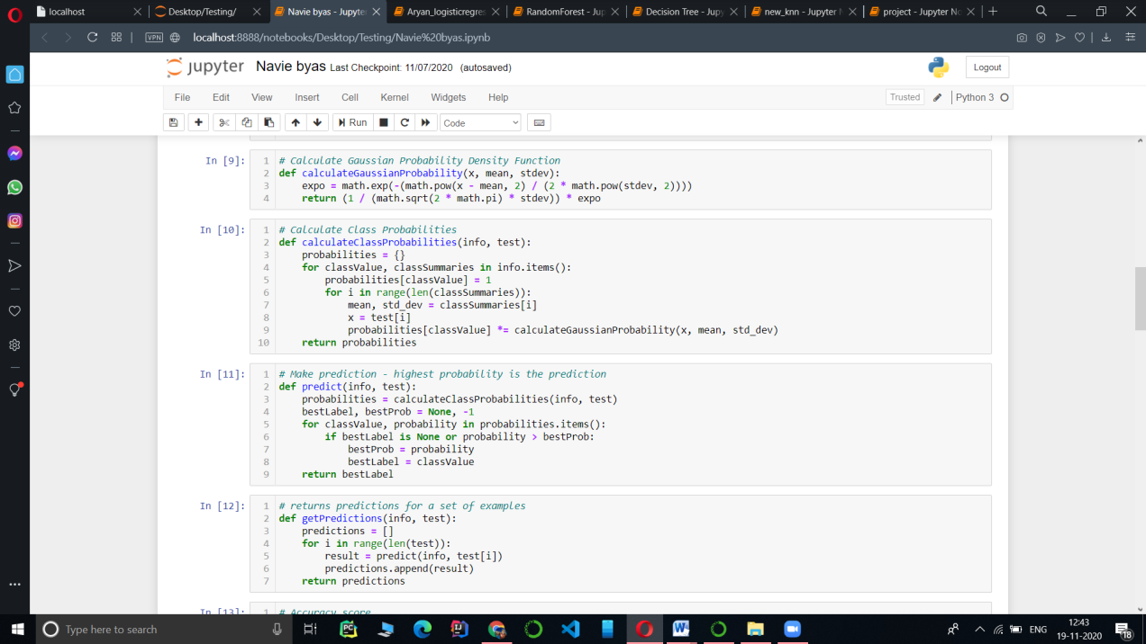

Figure 37:- Naïve Bayes Implementation

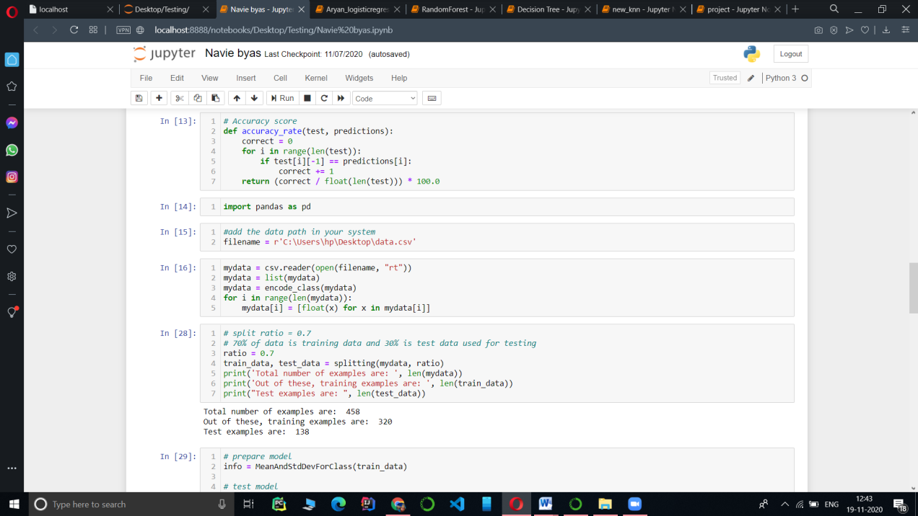

Figure 38- Naïve Bayes Implementation

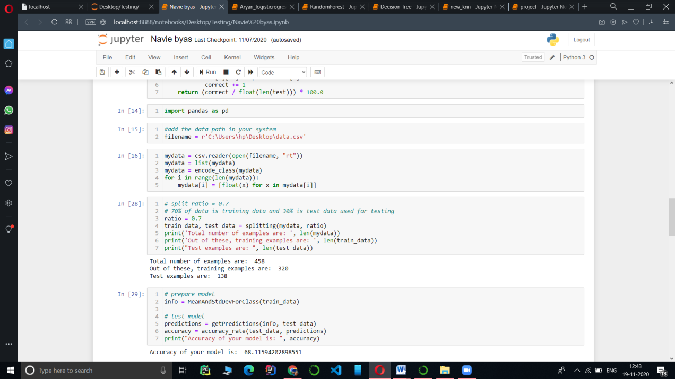

Figure 39- Naïve Bayes Implementation

**Chapter 5**

**Conclusion**

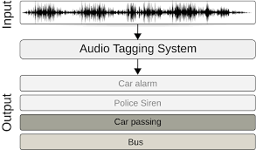

Figure 40 – Project Model

As Displayed Earlier we have applied 5 classification Algorithms in our project. In which we get maximum Accuracy in KNN algorithm at k = 3 which is 77% which varies with values of k such as at k = 5 it reduced to 72% at k = 7 it further reduced to 68% and at k=13 it reduced to 61. Which means we get Maximum accuracy at k=3(till now). Next we achieve 73% accuracy in Random Forest Algorithm and 68% accuracy in Naïve bayes Algorithm which varies from 68 – 60. In Decision Tree algorithm we achieve accuracy of 61%. And at last we get minimum accuracy in Logistic Regression algorithm which is 24%.

The table and Graph view to these-

Name Accuracy

0 Naive Bayes 68

1 KNN (k=3) 77

2 KNN (k=5) 72

3 KNN (k=7) 68

4 KNN (k=13) 61

5 Random Forest 73

6 Decision Tree 61

7 Logistic Regression 24

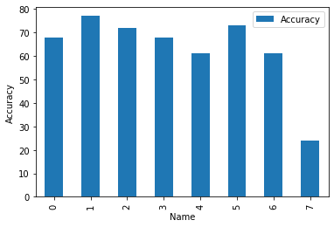

Figure 41- Conclusion

**Chapter 6**

**References**

1. https://scholar.google.com/

2. Tom Mitchell, "Machine Learning"

3. www.geeksforgeeks.com

4. www.youtube.com